ABSTRACT
A loan is when one or more people, organizations, or other entities lend money to other people, organizations, or entities. The recipient (i.e., the borrower) incurs a debt for which he or she is generally responsible for paying interest until the loan is repaid. The project's objective is to ensure that a person, institution, or organization applying for a loan is verified thoroughly before sanctioning them a loan. Several criteria like gender, education, number of dependents, to name a few, have to be taken into consideration before approving the loan. The project aims at automating the procedure, thus, helping in reducing the time and energy and making the process more efficient. Two sets of data-train data set and test data set -are given as the input. The train data set is used to train the Machine Learning Model and determine its accuracy. The test data set is used to output the loan eligibility predictions.

LIST OF FIGURES

FIGURE NO. DESCRIPTION PAGE NO

Fig 4.3.1 Data flow diagram 10
Fig 4.3.2 Use case Diagram 11

LIST OF ABBREVIATIONS

ABBREVIATION DESCRIPTION

CIBIL Credit Information Company
OMG Object Management Group

Table of Contents

ABSTRACT i LIST OF FIGURES ii LIST OF ABBREVIATIONS iii

CHAPTER 1: INTRODUCTION 1 1.1 Introduction 1 1.2 Existing System 2 1.3 Problem Statement 1.4 Proposed System
1.4.1 Proposed system 2 1.4.2 Objectives 3

CHAPTER 2: LITERATURE REVIEW 4

CHAPTER 3: REQUIREMENTS & DOMAIN INFORMATION 3.1 Requirement Specifications
3.1.1 Hardware Requirements 5 3.1.2 Software Requirements 5
3.2 Domain Information 6

CHAPTER 4: SYSTEM METHODOLOGY

4.1 Architecture of Proposed System 7 4.2Algorithm 8 4.3 System Design 9
4.3.1 Data Flow Diagrams 10 4.3.2 UML Diagrams 11

CHAPTER 5: EXPERIMENTATION & ANALYSIS

5.1 Experimentation 11 5.2 Results 17
5.2.1 Screenshots 12

5.3 Testing 18
5.3.1 Types of Testing

CHAPTER 6: CONCLUSION & FUTURE SCOPE
6.1 Conclusion 21 6.2 Future Scope 21 REFERENCE 22

CHAPTER 1

1. INTRODUCTION

1.1 INTRODUCTION
Loan Prediction is very helpful for employees of banks as well as for the applicant also. The aim of this project is to provide a quick, immediate and easy way to choose the deserving applicants. Customers first apply for a loan after that company or bank validates the customer eligibility for loan. Company or bank wants to automate the loan eligibility process (real time) based on customer details provided while filling application form. These details are Gender, Marital Status, Education, Number of Dependents, Income, Loan Amount, Credit History and other. This project has taken the data of previous customers of various banks to whom on a set of parameters loan were approved. So the machine learning model is trained on that record to get accurate results.
Our main objective of this project is to predict the safety of loans. To predict loan safety, the Random Forest algorithm is used. First the data is cleaned so as to avoid the missing values in the data set. Loan approval is a very important process for banking organizations. The system approved or reject the loan applications. Recovery of loans is a major contributing parameter in the financial statements of a bank. It is very difficult to predict the possibility of payment of loan by the customer. Using Machine learning we predict the loan Approval.

1.2 EXISTING SYSTEM
The current system, CIBIL, is a credit scoring system that collects and maintains records of individuals and commercial entities payments about loans and credit cards. These records are submitted to TransUnion, a Credit Information by banks and other lenders every month to every; using this an information, a CIBIL Score and Report for individuals is developed.
The CIBIL Score is a 3-digit numeric summary of a person's credit history, derived by using details found in the "Accounts and "Enquiries' sections on their CIBIL Report and ranges from 300 to 900. This enables lenders to evaluate and approve loan applications. Although the CIBIL Score plays a vital role in the loan application process, it doesn't necessarily paint the entire picture.

The CIBIL Score works as a first impression for the lender; the higher the score, the better are the chances of the loan being reviewed and approved. The decision to lend is solely dependent on the lender, who has to consider several other factors too. CIBIL does not in any manner decide if the loan/credit card should be sanctioned or not. The lender has to manually review cash application, based on the details provided by the applicant, such as Gender, Marital Status, Education, Number of Dependents. Income. Loan Amount, Credit history, etc., and decide if they are creditworthy.

1.3 PROBLEM STATEMENT
While sanctioning loans, banks, and other lending authorities need to have a surety of getting their money back along with interest on it. So, they need to know the credibility. of the borrower before lending the money. For this, the lending authorities need to verify the background and credibility of the borrower thoroughly. However, going through several variables and factors manually for every borrower is a time taking process and is highly inefficient.

1.4 PROPOSED SYSTEM 1.4.1 Proposed System
Proposed system automates the process of determining the applicant's creditworthiness. A data set containing the details of the loan applicants is collected. It is structured and analyzed using suitable analysis techniques. The data set is classified into two categories:
Train data is used for training the model. Le, our model will Learn from this file. It contains all the independent variables and the target variable.
Test data contains all the independent variables but not the target variable. We apply the model to predict the target. Variable for the test data.

1.1.4. Objectives
The main objective is to predict whether the loan approval to a specific individual is safe or not.
A random forest is a machine learning technique that’s used to solve regression and classification problems. It utilizes ensemble learning, which is a technique that combines many classifiers to provide solutions to complex problems.
A random forest algorithm consists of many decision trees. The ‘forest’ generated by the random forest algorithm is trained through bagging or bootstrap aggregating. Bagging is an ensemble metaalgorithm that improves the accuracy of machine learning algorithms.
The (random forest) algorithm establishes the outcome based on the predictions of the decision trees. It predicts by taking the average or mean of the output from various trees. Increasing the number of trees increases the precision of the outcome.
A random forest eradicates the limitations of a decision tree algorithm. It reduces the overfitting of datasets and increases precision. It generates predictions without requiring many configurations in packages.

CHAPTER 2

2. LITERATURE REVIEW
Regina EsiTurkson, Edward YeallakuorBaagyere, Gideon Evans Wenya [1] in their paper have delved into the various machine learning models that can be deployed in order to predict the loan eligibility of an applicant. They have employed 15 different learning algorithms on the Odata set in order to determine which algorithms are the best fit for studying bank credit data sets. Neural Networks, Discriminant Analysis, Naive Bayes, K-Nearest Neighbor, Linear Regression, Decision Trees, Ensemble. Learning/method, Logistic Regression are some of the algorithms used.
The experiment revealed that apart from the Nearest Centroid and Gaussian Naïve Bayes the rest of the algorithms work well in terms of their accuracy rate and other performance evaluation metrics. Each of this. Algorithms produce an accuracy rate about 76% to over 80%. Using loan eligibility prediction as an example, the author explains how random forest can be used to design a Machine Learning model that takes decisions based on several variables such as gender, income, employment status, dependents, etc. to give a final result as to whether the borrower in question is eligible for a loan or not.
They compared these results to the results given by the banks' systems which mainly focus on the account information (which shows the wealth of the applicant). After testing and comparisons, the authors notice that the Random Forest Model produced marginally better output due to the consideration of several other factors like age, purpose, credit history, credit duration, etc.

CHAPTER 3

3. REQUIREMENTS & DOMAIN INFORMATION

3.1 REQUIREMENT SPECIFICATION

3.1.1 Hardware Requirements
Operating system: Windows/Ubuntu
Processor: Intel Core i5 7th Gen 2.50GHz
RAM: 8GB

3.1.2 Software Requirements
Supporting software: Python/Anaconda Navigator, Numpy, Pandas, sklearn, Matplotlib
Python’s ecosystem is growing over the years and it’s more and more capable of the statistical analysis. It’s the best compromise between scale and sophistication (in terms OD data processing).
Python emphasizes productivity and readability. Python is used by programmers that want to develop into data analysis or apply statistical techniques.
There are plenty of Python scientific packages for data visualization, machine learning, natural language processing, complex data analysis and more. All of these factors make Python a great tool for scientific computing and a solid alternative for commercial packages such as Matlab. The most popular libraries and tools for data science are:

PANDAS
Panda's name is derived from the term “panel data”, an econometrics term for multidimensional structured data sets. It is a library for data manipulation and analysis. The library provides data structures and operations for manipulating numerical tables and time series. It is also known as “Python Data Analysis
Library”

NUMPY
Numpy is a general-purpose array-processing package. It provides a high-performance multidimensional array object, and tools for working with these arrays. This is a fundamental package for scientific computing with Python, adding support for large, multi-dimensional arrays and matrices, along with a large library of high-level mathematical functions to operate on these arrays.

MATPLOTLIB
Matplotlib is a python 2D plotting library which produces publication quality figures in a variety of hardcopy formats and interactive environments across platforms. Matplotlib allows you to generate plots, histograms, power spectra, bar charts, error charts, scatterplots, and more.

3.2 DOMAIN INFORMATION
Machine learning is a method of data analysis that automates analytical model building. It is a branch of artificial intelligence based on the idea that systems can learn from data, identify patterns and make decisions with minimal human intervention.
In our project we use a random forest Algorithm. A random forest is a machine learning technique that’s used to solve regression and classification problems. It utilizes ensemble learning, which is a technique that combines many classifiers to provide solutions to complex problems.
A random forest algorithm consists of many decision trees. The ‘forest’ generated by the random forest algorithm is trained through bagging or bootstrap aggregating. Bagging is an ensemble metaalgorithm that improves the accuracy of machine learning algorithms.
The (random forest) algorithm establishes the outcome based on the predictions of the decision trees.
It predicts by taking the average or mean of the output from various trees.

CHAPTER 4

4. SYSTEM METHODOLOGY
4.1.1 ARCHITECTURE OF PROPOSED DESIGN

1. Data Collection
- The quantity & quality of your data dictate how accurate our model is.
- The outcome of this step is generally a representation of data which we will use for training.
- Using pre-collected data, by way of datasets from Kaggle, UCI, etc. still fits into this step.

2. Data Preparation
- Wrangle data and prepare it for training.
- Clean that which may require it (remove duplicates, correct errors, deal with missing values, normalization, data type conversions, etc.).
- Randomize data, which erases the effects of the particular order in which we collected and/or otherwise prepared our data.
3. Choose a Model
● Different algorithms are for different tasks; choose the right one.

4. Train the Model
- The goal of training is to answer a question or make a prediction correctly as often as possible.
- Linear regression example: algorithm would need to learn values for m (or W) and b (x is input, y is output).
- Each iteration of the process is a training step.

5. Evaluate the Model
- Uses some metric or combination of metrics to "measure" objective performance of model.
- Test the model against previously unseen data.
- This unseen data is meant to be somewhat representative of model performance in the real world, but still helps tune the model (as opposed to test data, which does not).
- Good train/evaluate split 80/20, 70/30, or similar, depending on domain, data availability, dataset particulars, etc.

6. Parameter Tuning
- This step refers to hyper-parameter tuning, which is an "art form" as to a science.
- Tune model parameters for improved performance.
- Simple model hyper-parameters may include: number of training steps, learning rate, initialization values and distribution, etc.

7. Make Predictions
● Using further data which have, until this point, been withheld from the model are used to test the model; a better approximation of how the model will perform in the real world.

4.2 ALGORITHM
Random Forest works in two-phase first is to create the random forest by combining N decision trees, and second is to make predictions for each tree created in the first phase.
The Working process can be explained in the below steps and diagram:
Step-1: Select random K data points from the training set.
Step-2: Build the decision trees associated with the majority votes. the selected data points.
Step-3: Choose the number N for decision trees that you want to build.
Step-4: Repeat Step 1 & 2.
Step-5: For new data points, find the predictions of each decision tree, and assign the new data points to the category that wins Random Forest is a popular machine learning algorithm that belongs to the supervised learning technique. It can be used for both Classification and Regression problems in ML. It is based on the concept of ensemble learning, which is a process of combining multiple classifiers to solve a complex problem and to improve the performance of the model.
As the name suggests, "Random Forest is a classifier that contains a number of decision trees on various subsets of the given dataset and takes the average to improve the predictive accuracy of that dataset." Instead of relying on one decision tree, the random forest takes the prediction from each tree and based on the majority votes of predictions, and it predicts the final output.
The greater number of trees in the forest leads to higher accuracy and prevents the problem of overfitting.

Advantages of Random Forest
Random Forest is capable of performing both Classification and Regression tasks.
It is capable of handling large datasets with high dimensionality.
It enhances the accuracy of the model and prevents the overfitting issue.

Disadvantages of Random Forest
Although random forest can be used for both classification and regression tasks, it is not more suitable for Regression task.

4.3 SYSTEM DESIGN
All the raw data is fed into the machine which cleans and processes it for accurate testing and training. The train data set is fed into the classification model, which determines the accuracy of the model.
The test data set is fed into the machine learning model. Finally, using the information given by the classification model and the train data set, the Machine Learning Model predicts whether the applicant is worthy of the monetary loan or not.
Python is a language used to implement the project. The output of the project is dichotomous, according to the problem statement. The desired output will be obtained by fitting the data into a logistic regression model for multiple independent variables.

4.3.1 DATA FLOW DIAGRAMS
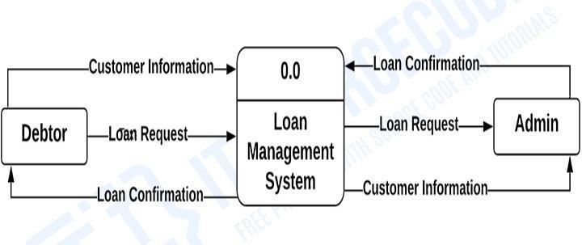
4.3.1 Data Flow Diagram

4.3.2 UML DIAGRAMS
Use Case Diagram:
- UML is a standard language for specifying, visualizing, constructing, and documenting the artifacts of software systems.
- UML was created by Object Management Group (OMG) and UML 1.0 specification draft was proposed to the OMG in January 1997.
- OMG is continuously putting effort to make a truly industry standard.
- UML stands for Unified Modeling Language.
The middle compartment contains the attributes of the class. They are left-aligned and the first letter is lowercase.

The bottom compartment contains the operations the class can execute. They are also left-aligned and the first letter is lowercase.
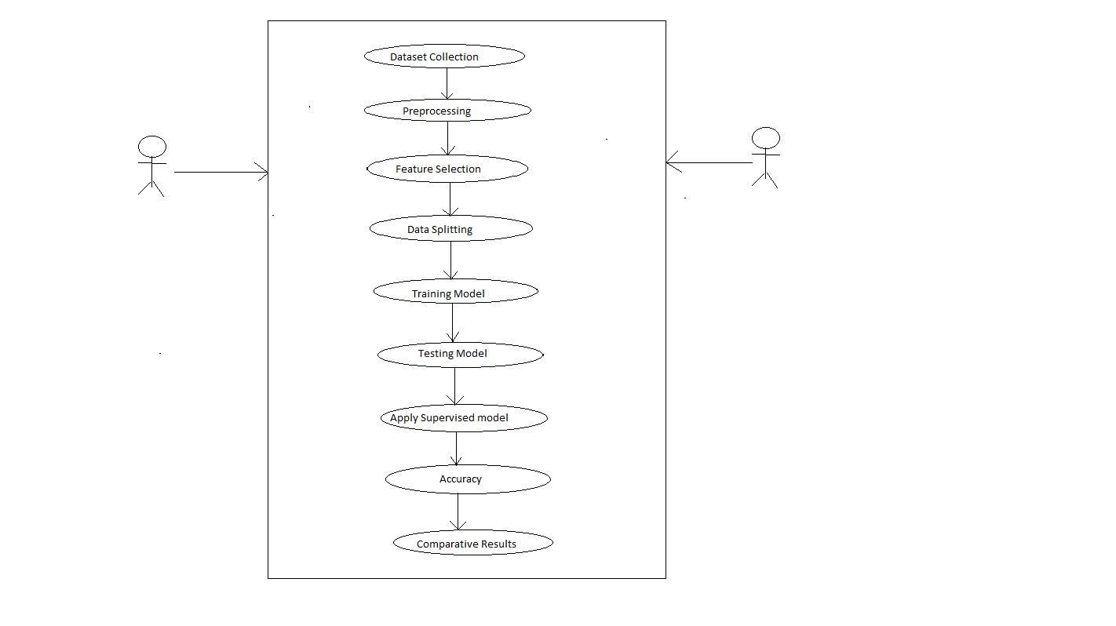
Fig.4.3.2: Use Case Diagram

CHAPTER 5

5. SYSTEM METHODOLOGY & ANALYSIS

5.1 EXPERIMENTATION
# Steps to solve machine learning projects
- Start
- Data selection
- Data description: A story of data is all about and the features present in the data
- Performing both statistical and graphical data analysis
- Data transformation and derivation of new attributes, if necessary
- Selection of machine learning algorithms based on the patterns observed in EDA
- Data standardization and normalization
- Creation of train and test data sets
- Model training using machine learning algorithms
- Calculation of model accuracy: both training and testing accuracy
- Hyper parameter tuning to achieve a better accuracy
- Saving the created model file
- Deployment strategies for model
- Production deployment and testing

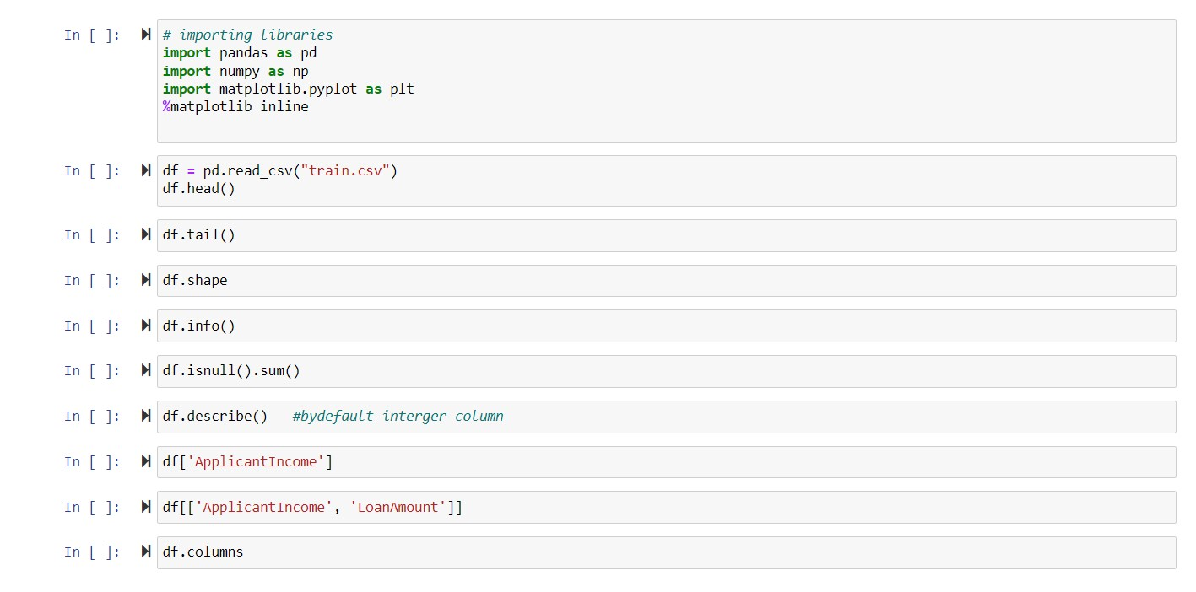

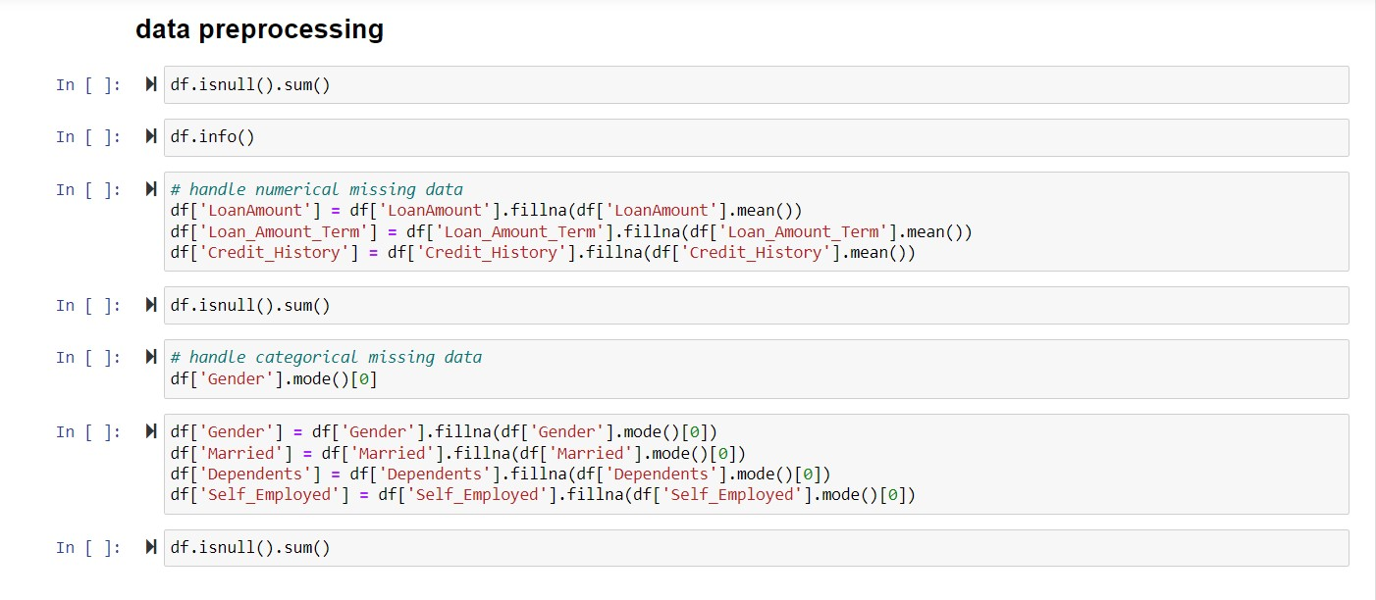
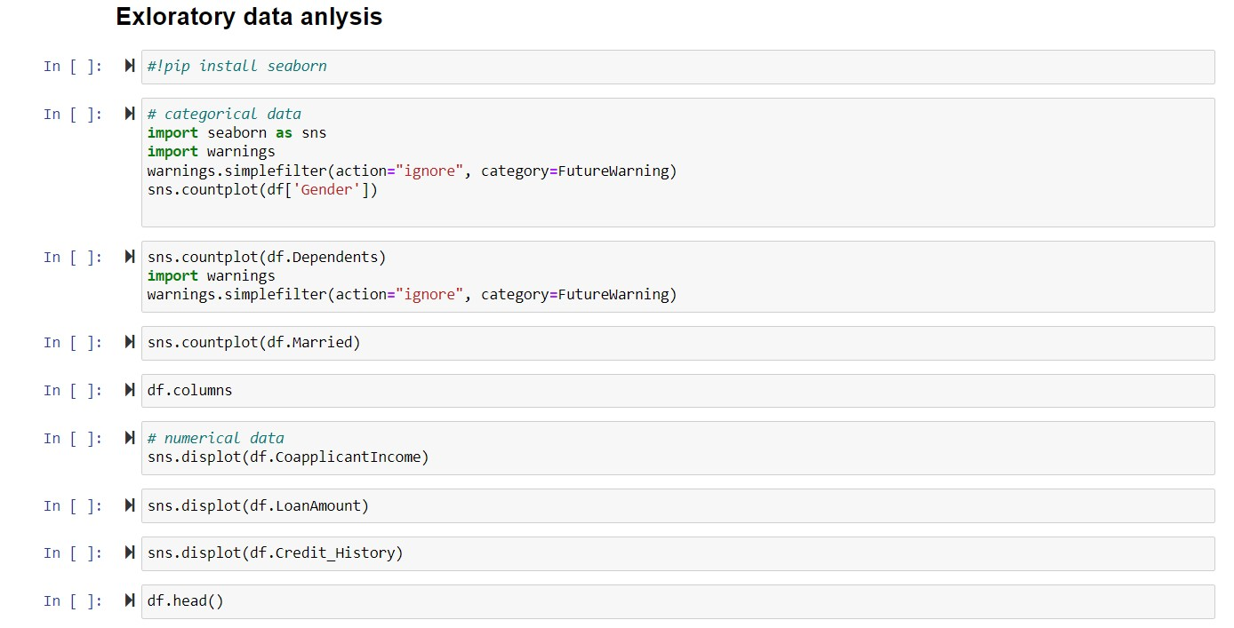

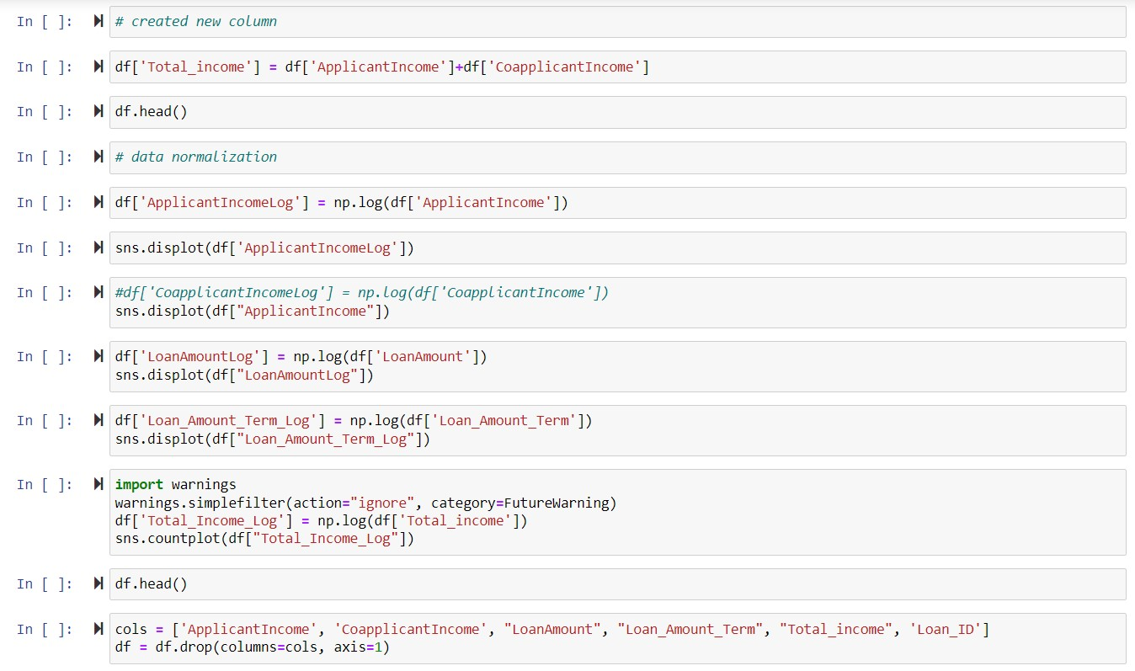
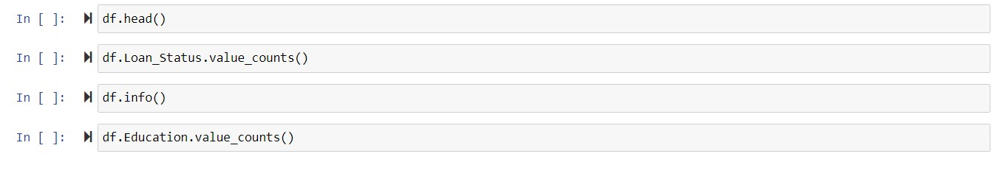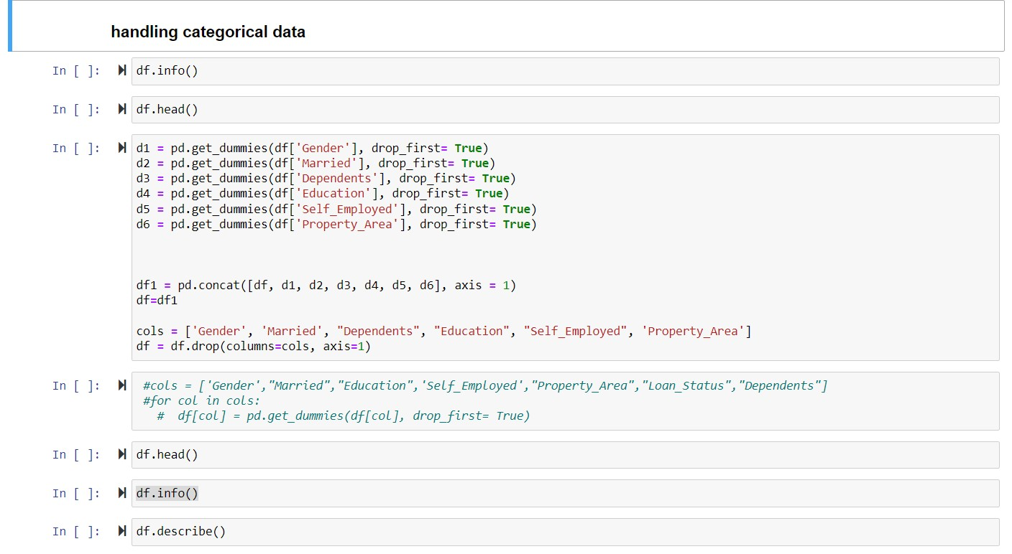

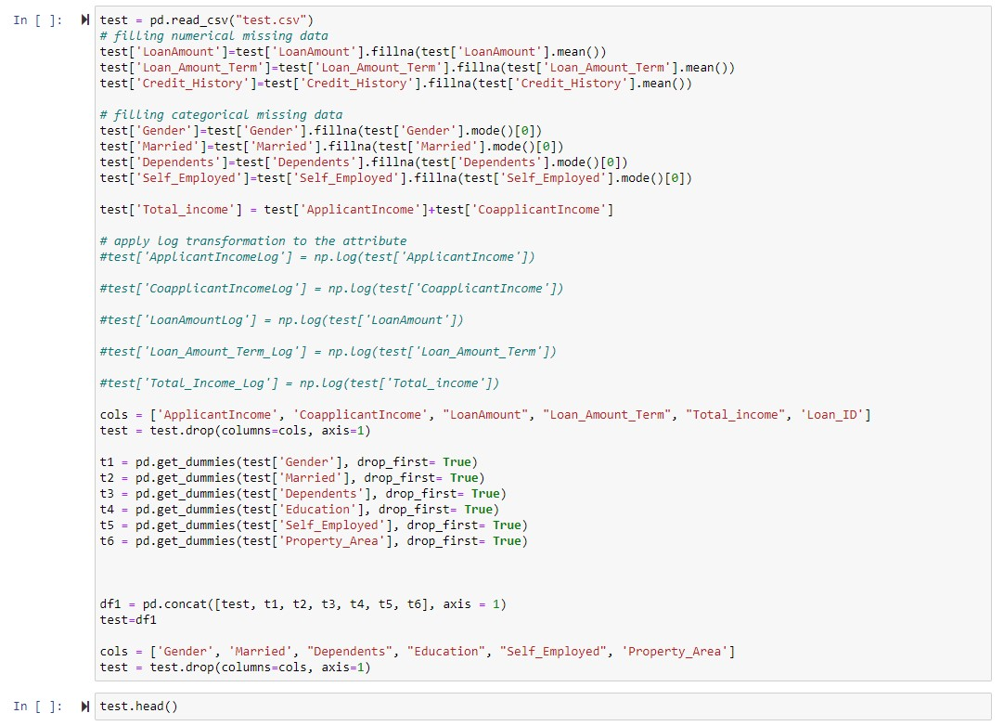

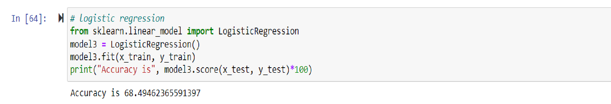
RESULT:
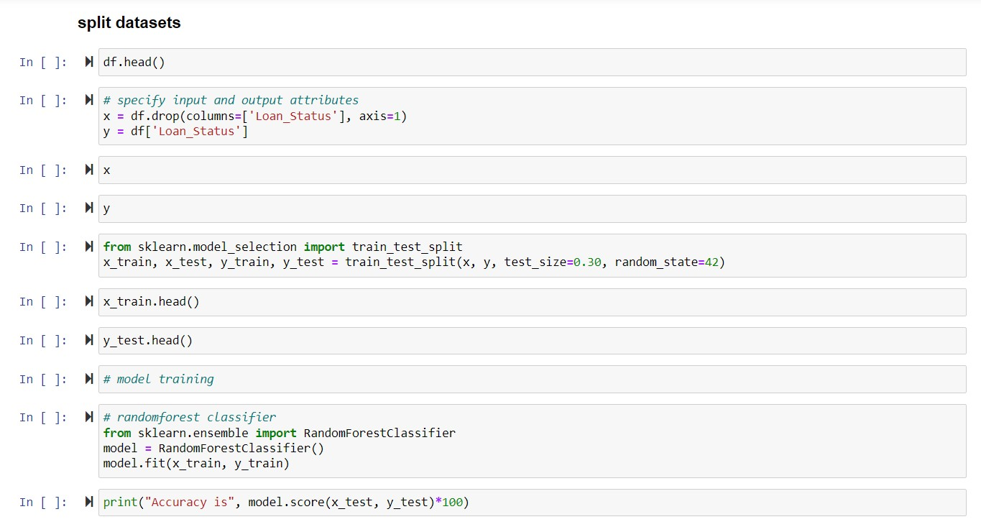

Accuracy result with Random forest
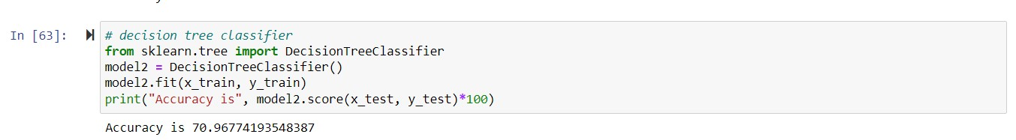
Accuracy result with Decision Tree
Accuracy result with Logistic Regression

5.3 TESTING

Software Testing
Software testing is an investigation conducted to provide stakeholders with information about the quality of the product or service under test. Software Testing also provides an objective, independent view of the software to allow the business to appreciate and understand the risks at implementation of the software. Test techniques include, but are not limited to, the process of executing a program or application with the intent of finding software bugs.
Software Testing can also be stated as the process of validating and verifying that a software program/application/product:
- Meets the business and technical requirements that guided its design and Development.
- Works as expected and can be implemented with the same characteristics.

5.3.1 TYPES OF TESTING
While reporting evaluation metrics is certainly a good practice for quality assurance during model development, I don't think it's sufficient. Without a granular report of specific behaviours, we won't be able to immediately understand the nuance of how behaviour may change if we switch over to the new model. Additionally, we won't be able to track (and prevent) behavioral regressions for specific failure modes that had been previously addressed. This can be especially dangerous for machine learning systems since often times failures happen silently. For example, you might improve the overall evaluation metric but introduce a regression on a critical subset of data. Or you could unknowingly add a gender bias to the model through the inclusion of a new dataset during training. We need more nuanced reports of model behaviour to identify such cases, which is exactly where model testing can help. For machine learning systems, we should be running model evaluation and model tests in parallel.
•Model evaluation covers metrics and plots which summarize performance on a validation or test dataset.
- Model testing involves explicit checks for behaviors that we expect our model to follow. Both of these perspectives are instrumental in building high-quality models. In practice, most people are doing a combination of the two where evaluation metrics are calculated automatically and some level of model "testing" is done manually through error analysis (i.e. classifying failure modes). Developing model tests for machine learning systems can offer a systematic approach towards error analysis.
There are two general classes of model tests that we'll want to write.
- Pre-train tests allow us to identify some bugs early on and short-circuit a training job.
- Post-train tests use the trained model artifact to inspect behaviors for a variety of important scenarios that we define.
Pre-Train Tests
There are some tests that we can run without needing trained parameters. These tests include:
- check the shape of your model output and ensure it aligns with the labels in your dataset
- check the output ranges and ensure it aligns with our expectations (e.g. the output of a classification model should be a distribution with class probabilities that sum to 1)
- make sure a single gradient step on a batch of data yields a decrease in your loss
- make assertion about your datasets
- check for label leakage between your training and validation datasets
Post-Train Tests
However, in order for us to be able to understand model Behaviour we'll need to test against trained model artifacts. These tests aim to interrogate the logic learned during training and provide us with a behavioral report of model performance.
- Invariance tests. Using invariance tests, we can check how much we can change the input without it affecting the performance of the model. We can pair up input examples and check for consistency in predictions. For example, if we run a pattern recognition model on two different photos of red apples, we expect that the result will not change much.
- Directional expectation tests. Unlike invariance tests, directional expectation tests are needed to check how perturbations in input will change the behavior

of the model. For example, when building a regression model that estimates the prices of houses and takes square meters as one of the parameters, we want to see that adding extra space makes the price go up.
- Minimum functionality tests. These tests enable us to test the components of the program separately just like traditional unit tests. For example, you can assess the model on specific cases found in your data.

CHAPTER 6

6. CONCLUSION AND FUTURE SCOPE

6.1 CONCLUSION
So here, it can be concluded with confidence that the Random forest model is extremely efficient and gives a better result when compared to other models. It works correctly and fulfills all requirements of bankers. This system properly and accurately calculates the result. It predicts the loan is approve or reject to loan applicant or customer very accurately

6.2 FUTURE SCOPE
In this paper, we have presented a loan credibility prediction system that helps the organizations in making the right decision to approve or reject the loan request of the customers. This will definitely help the banking industry to open up efficient delivery channels. Decision Tree Induction Algorithm is used for the prediction. Incorporation of other techniques that outperform the performance of popular data mining models have to be implemented and tested for the domain.

REFERENCE
- Dileep B. Desai, Dr. R.V.Kulkarni A Review: Application Of Data Mining Tools In Crm For Selected Banks, (Ijcsit) International Journal Of Computer Science And Information Technologies, Vol. 4 (2), 2013, 199 201.
- Rob Gerritsen, Loan Risks: A Data Mining Case Study.
3.Dr. K. Chitra1, B. Sabatini, Data Mining Techniques And Its Applications In Banking Sector , International Journal Of Emerging Technology And
Advanced Engineering Website: Www.Ijetae.Com (Issn 2250-2459, Iso 9001:2008 Certified Journal, Volume 3, Issue 8, August 2013)
- Dr. Madan LalBhasin, Data Mining: A Competitive Tool In The Banking And Retail Industries, The Chartered Accountant October 2006
- Frawley, W. J., Piatetsky-Shapiro, G., And Matheus, C. J. (1992). Knowledge Discovery In Databases: An Overview. Ai Magazine, 13(3):57.

